Ideation Phase
Empathize & Discover

Date | 20 February 2026
Team ID | LTVIP2026TMIDS66673
Project Name | Plugging into the Future: An Exploration of Electricity Consumption Patterns Using Tableau
Maximum Marks | 4 Marks

Empathy Map Canvas:
An empathy map is a simple visual tool used to understand the needs, behaviors, and challenges of users involved in electricity consumption analysis. In this project, it focuses on electricity analysts and energy planners who analyze consumption patterns to support efficient energy management.
The empathy map helps identify user goals, such as understanding peak demand and usage trends, along with challenges like complex datasets and lack of interactive visualizations. This understanding ensures the Tableau dashboards are user-centric and support informed, data-driven decision-making.
Example:
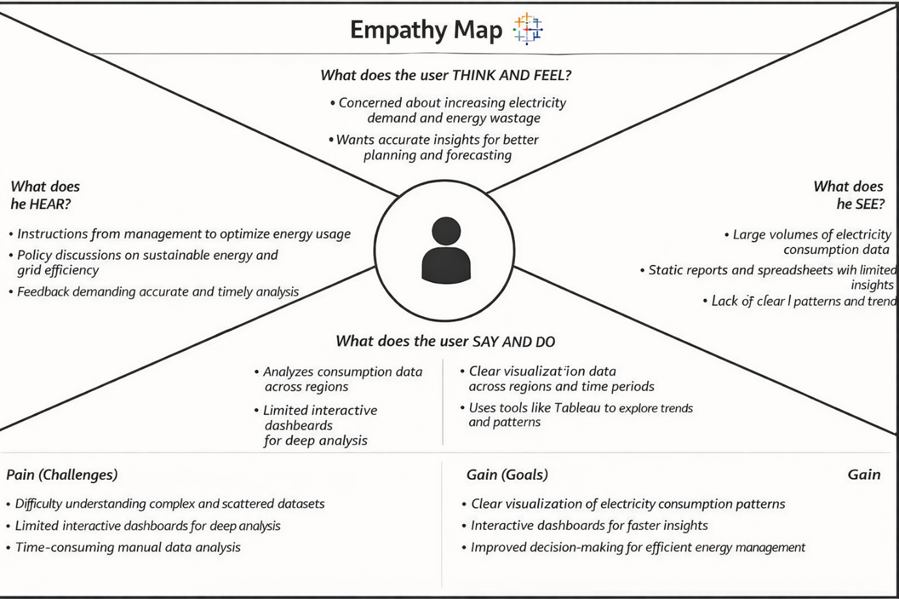

Reference: https://www.mural.co/templates/empathy-map-canvas

Example:

